Lesson Plan/Ideas
The Pentagon Papers and the Freedom of the Press

Materials collected and prepared by
Jeffery D. Nokes, Zachary Baldauf, Miriam Castle, Bobby Dayley,
Katherine Hardy, Cameron Helvey, Kendelle James, and Kara Olsen
Brigham Young University

Background
One of the greatest tests in our nation’s history of the Freedom of the Press took place in 1971 when the New York Times published excerpts from the top secret “Pentagon Papers.” In a controversial 6-3 decision, the Supreme Court allowed the publication to continue, in spite of the damage that some claimed it would do to the ongoing Vietnam War. The controversial nature of the case provides students with an opportunity to consider essential questions about balancing freedoms with maintaining security. This lesson could be taught in connection with having students watch the movie The Post, a 2017 film depicting the decision of Washington Post owner, Katherine Graham, to publish the Pentagon Papers after a court injunction temporarily halted the New York Times from publishing them.

Objectives
- Students will use sourcing, corroboration, and contextualization to analyze historical evidence.
- Students will use evidence to develop an interpretation of Daniel Ellsberg’s actions in relation to the Espionage Act of 1917.
- Students will use evidence to develop an interpretation of the Supreme Court’s decision to allow the publication of the Pentagon Papers.
- Students will consider the need to balance freedoms (like freedom of the press) with security (like national defense).

Time
This lesson is expected to take approximately 90 minutes of class time, with students doing some additional reading and/or writing outside of class. Teachers could reduce the time required to teach this lesson by assigning students to read the background material and several of the documents outside of class, or by using fewer documents than those included.

Materials
- Student Background Information: Provides students with simplified background information needed to analyze the documents related to the publication of the Pentagon Papers. The information is presented as seven items that most historians would agree on.
- Graphic Organizer: This worksheet is designed for students to keep a record as they analyze documents, supporting their use of sourcing. Alternatively, students might simply annotate the documents.
- Document Packet for Students: A collection of twelve documents related to the publication of the Pentagon Papers including the Espionage Act, excerpts from Daniel Ellsberg’s autobiography, excerpts from the New York Times and the Pentagon Papers, A transcript of a Nixon/Kissinger telephone conversation, and concurring and dissenting opinions issued by Supreme Court justices. Many of these documents have been translated into simpler language, written at about the eighth-grade level.
- Teacher Background Information: These materials mirror the Student Background Information, however the teacher materials are written in a more complex way and describe events and conditions in greater detail than the simple materials given to students so that teachers will have a deeper understanding of the event.
- Original Documents: This is a collection of unedited excerpts of the five documents that are modified in the students’ document packet. These are made available in case students or the teacher want to compare the modified documents given to the students to the original documents. Materials in the Document Packet for Students that were not modified are not included in this packet.

Preparation
- Review the Teacher Background Information to build background knowledge on the publication of the Pentagon Papers.
- Make a classroom set of the Student Background Information papers and the Document Packet for Students.
- Make a copy of the Graphic Organizer: The Pentagon Papers and Freedom of the Press for each student.
- Consider appropriate groups of students that would allow those with greater skills in reading and historical thinking to help those with weaker skills.
- Preview The Post, and consider the debriefing questions included in Procedure 11 below.

Procedures
- Provide students with background information on the Pentagon Papers and the Freedom of the Press. This can be done through a brief lecture or it can be accomplished by having students independently read and discuss their Student Background Information sheets.
- Explain to students the instructions for completing the Graphic Organizer. These instructions are found on the top of the first page of the graphic organizer. Model for students your thought processes as you analyze the source of the first document, showing them how to complete the graphic organizer as you do. For example, as you start by reading the modified Espionage Act (Document 1), you might say:
“I can see that this bold information on the top of the paper tells me about the source. I know that it is important to consider the source of historical documents—a strategy called ‘sourcing.’ It looks like this is an act passed by Congress in 1917 called the Espionage Act. I wonder what a law passed in 1917 has to do with the Pentagon Papers. OK, I see as I read on that this law was used to prosecute Ellsberg, the guy who leaked the Pentagon Papers. Now I remember that our assignment is to see whether Ellsberg violated the Espionage Act, so it makes sense we have to look at the law….
- You might model completing the graphic organizer by projecting something like this for students to see:

Doc | Genre | Source | Evidence for/against Ellsberg | Evidence for/against publishing excerpts
1 | Law | 1917 Congress-in response to WWI

- Continue reading the document, pausing to analyze it as you go. For example, you might make the following observations for students as you complete the first column of the graphic organizer:
“The words from the law that jump out at me are ‘trusted with’ and ‘copies’ and ‘writing,’ because Ellsberg did make copies of top secret writing he had been trusted with. The part I don’t know about was whether it did harm to the U.S. or helped a foreign nation. I guess the other documents might tell me more about that, but I’ll still say it might have harmed the US. I think this document just helps us know about the first question and doesn’t really help us much with the Supreme Court decision so I can leave that space blank.”
- You might project this information to show how students can complete their graphic organizer.
Doc | Genre | Source | Evidence for/against Ellsberg | Evidence for/against publishing excerpts
1 | Law | 1917 Congress-in response to WWI | From the background I know Ellsberg was trusted with top secret writing and he made copies and it may have done harm to the U.S.

- Depending on the students’ reaction to the first document and their understanding of the process of historical analysis, you can model the analysis of the second document as you did the first one. Or you might have students work with a partner to analyze the second document, then regroup as a class and discuss what they came up with. You might display the next row of the graphic organizer and see whether the students came up with the same ideas you did. Additionally, you can show students connections between the two documents by saying something like this:
“It looks to me like Ellsberg might have been trying to defend himself by suggesting that what he was doing was intended to help rather than harm America. After all, he published the book the same year that the New York Times published the Pentagon Papers and he was being prosecuted for violating the Espionage Act. He may be suggesting that he didn’t violate the Espionage Act because he wasn’t trying to do harm, but instead was trying to help America by ending the war. But I have to remember that this is Ellsberg talking and so it might not have mattered whether he thought he was helping America if, in fact he was really causing America harm. Comparing and contrasting ideas across documents, like we have done with the Espionage Act and Ellsberg’s statement in his book, is called ‘corroboration.’”

Doc | Genre | Source | Evidence for/against Ellsberg | Evidence for/against publishing excerpts
1 | Law | 1917 Congress-in response to WWI | From the background I know Ellsberg was trusted with top secret writing and he made copies and it may have done harm to the U.S.
2 | Book | Written by Ellsberg in 1973, same year the NY Times published the Pent. Papers. Ellsberg on trial | Ellsberg doesn’t deny leaking the papers but claims he did it to expose problems with govt. and stop the war | Ellsberg argues that publishing the papers is a way to seek moral and political change and stop immediately the crime of the war

- Once you are confident the students understand the process of analyzing the documents and completing the graphic organizer, you can give them time to work in teams on the remaining documents, circulating as they work to give support. Give students time to answer the questions at the bottom of their graphic organizer about Ellsberg, the publishing of the Pentagon Papers, and balancing freedoms and security.
- After all of the documents have been analyzed, bring the entire class back together for a debriefing session. Ask the students questions like the following and allow them to discuss and respectfully critique others’ responses.
- In your opinion, was Ellsberg guilty of violating the Espionage Act of 1917? Why or why not? What evidence helped you develop this interpretation? What additional evidence would have helped reach a conclusion?
- In your opinion, was the Supreme Court correct in allowing the New York Times to publish excerpts from the Pentagon Papers? Why or why not? What evidence helped you develop this interpretation?
- Which documents did you trust the most? Which did you trust the least? (You could even have students rank the documents in trustworthiness). What were some of the things that made documents seem more trustworthy or less trustworthy to you?
- In your opinion, what are the best ways to balance the freedom of the press with national security? What are the reasonable limits on freedom of the press?
- In the discussion of controversial issues, you might provide students with strategies for interacting with peers. For instance, students could be given the following guidelines for working with someone who has a different opinion.
- Listen—really think about their ideas without being distracted by your response.
- Restate their ideas back to them to make sure you understand them.
- Acknowledge areas of agreement between you and them.
- Think about why they might have the opinion that they do based upon their background and understanding.
- Acknowledge that they are sincere and are not dumb, rude, or evil.
- Consider the strengths and weaknesses of their evidence.
- Think about how your ideas might be improved based on their good ideas.
- Wait until it is your turn to talk.
- Don’t view the differences between your ideas as a personal attack.
- Avoid losing your temper, raising your voice, or making a personal attack.
- Don’t be afraid to express your ideas even if they are different from someone else’s.
- Use evidence to support your ideas or to question their ideas.
- After the activity, students might be assigned to watch The Post, a movie depicting the decision made by the Washington Post to publish excerpts from the Pentagon Papers after a court injunction had caused the New York Times to temporarily stop publishing them. In preparation for watching this movie, the teacher might have students use the website History vs. Hollywood to review the accuracies and inaccuracies in the film at http://www.historyvshollywood.com/reelfaces/the-post/ If this site is used, explain to students that “reel” refers to the movie reel and “real” refers to historical accuracy.
- If students view the movie, you might follow-up with a debriefing. The following questions might be used:
- How did the movie portray the treatment of women during the early 1970s? Do you think this portrayal was accurate? What evidence would help us know whether women were really treated this way? Does this discrimination continue into the 21st century? In what ways is discrimination against women shown today? In what ways have things become better?
- Consider the scene where Katherine Graham (Meryl Streep) is leaving the courtroom, with young women looking admiringly at her. Do you think this moment actually happened? Even if it did not, how does this moment in the movie capture the context of the time? How is it that movies (and all types of historical fiction) can be literally inaccurate but conceptually accurate at the same time?
- Because movies need a villain, movie producers sometimes exaggerate the villainy of some individuals. How does the portrayal of President Nixon in the movie fulfill the need of a movie-going audience? Was he really a villain in the story of the leaking and publication of the Pentagon Papers and government efforts to stop that publication? Why or why not?
- The movie makes the Supreme Court decision seem indisputably correct. However, three supreme court justices dissented (disagreed with the decision of the majority). How could the producers of a movie spin things to make it seem like those three justices were correct and the other six were wrong?
- What are current/ongoing examples of “whistle-blowing?” Do “whistle-blowers,” like Daniel Ellsberg, ever cross the line of prudence?

Assessments
- Use the first two columns of the graphic organizer to assess students’ sourcing—their ability to use source information to critically analyze the content of a document. Students should not just include the name of the person who produced the document, but think about the person’s audience, purposes, perspectives, biases, insights, etc.
- Use the last two columns of the graphic organizer and their answers to the questions at the bottom of the paper to assess their ability to gather evidence from the documents and use evidence to support an opinion.
- During the debriefing session, assess the students’ ability to engage in contextualization—the ability to understand the historical context and social context of the publication of the Pentagon Papers. Students demonstrate contextualization when they realize that conditions, expectations, values, and norms in the past were different than those of the present.
- During the analysis of evidence, observe students’ ability and tendency to discuss issues civilly with other class members, particularly those who have a different opinion. Use a spreadsheet with each students’ name to keep a record of whether they use the strategies listed above (see #9 under procedures) for interacting with others.

Adaptations/Extensions
- For students who have trouble writing, instead of having them fill out the graphic organizer you might have them highlight the documents with different colors for those parts that provide evidence on either question. They could also take notes in the margins of the documents.
- For excellent readers, you could make packets of the original documents (rather than the simplified documents) and let them analyze the original texts.

Student Background Information
The Pentagon Papers and Freedom of the Press

An ongoing question throughout U.S. history is “what are the best ways to protect civil rights without risking national security?” Should newspapers or other media be allowed to publish information that could harm national defense? What are the reasonable limits on freedom of the press? Should those who leak sensitive information to the press be prosecuted as traitors, or viewed as heroes if their “whistleblowing” leads to positive change? These questions are central to the debate over the leaked Pentagon Papers and the publishing of their contents in the New York Times, the Washington Post, and other newspapers. Controversy still surrounds the original publication of the Pentagon Papers, though here are a few facts that most historians agree on:

- Before World War II, Vietnam was a French colony. After the war, the U.S. was afraid communism might spread into Vietnam. The U.S. became involved in France’s struggle to keep Vietnam and in Vietnam’s independence movement. In 1961, the United States’ military assumed a major role in fighting communists in Vietnam. U.S. military action in Vietnam, which continued until 1975, is called the Vietnam War.
- In 1967, while the war was being fought, the Secretary of Defense, Robert McNamara, created the “Vietnam History Task Force” and asked them to write a report summarizing U.S. involvement in Vietnam. Their report, the “Pentagon Papers,” was over 7,000 pages. It described U.S. relations with Vietnam from 1945-1967, and included details of American mistakes and failed strategies, claimed that government officials had lied to the American public, and provided other information that could embolden American enemies in Vietnam. The government classified the Pentagon Papers as “top secret.”
- Daniel Ellsberg helped write the Pentagon Papers. After traveling to Vietnam and studying the war, Ellsberg began to think that the Vietnam War was unjust. He started to attend anti-war events. In 1969, he decided to photocopy and share the Pentagon Papers with some anti-war senators and a New York Times newspaper reporter, Neil Sheehan.
- In June 1971, the New York Times began to publish excerpts from the Pentagon Papers with commentary. President Richard Nixon viewed the publication of the excerpts as treasonous. He convinced the courts to order the New York Times to stop publishing.
- Two weeks later, by a vote of 6 to 3, the U.S. Supreme Court ruled that the New York Times could again publish articles containing excerpts from the Pentagon Papers. This case of the New York Times Co. v. United States is an important test of the free press.
- Ellsberg shared the Pentagon Papers with other reporters, including some from the Washington Post, and with senators. Within a few months, more than half of the Pentagon Papers were available to the public through the Congressional Record.
- Ellsberg and a friend were charged with violating the Espionage Act of 1917. The case against them was dismissed when court officials discovered that Nixon’s team had used illegal means to gather evidence against Ellsberg.

You will be given a number of documents related to the publication of the Pentagon Papers. You will need to answer the questions: “Was Ellsberg guilty of violating the Espionage Act of 1917?” And, “was the Supreme Court wise in allowing the New York Times to publish excerpts from the Pentagon Papers?” You can annotate the documents, or use the following graphic organizer to gather evidence to support your conclusion.
Graphic Organizer: The Pentagon Papers and Freedom of the Press

You will be given a number of documents related to the Pentagon Papers and the related Supreme Court case. These documents show different people’s perspectives about the publication of the Pentagon Papers. As you read these documents, consider these questions: Was Ellsberg guilty of violating the Espionage Act of 1917? Was the Supreme Court prudent to allow the New York Times to publish excerpts? Use the following worksheet (or annotate the documents) in order to gather evidence to support your opinion. Consider the genre (whether it comes from a court decision, a private telephone conversation, etc.), and the source (who said it, who they were talking to, why they said it) as you analyze the documents. Then summarize the evidence each document provides for or against Ellsberg, and for or against the publication of the Pentagon Papers. Use the evidence you gather to answer the questions that follow.

Doc | Genre | Source | Evidence for/against Ellsberg | Evidence for/against publishing excerpts
1

2

3

4

5

6

7

8

9

10

11

12

- Was Ellsberg guilty of violating the Espionage Act of 1917? What evidence is most convincing?

- Was the U.S. Supreme Court correct in allowing the New York Times to publish excerpts from the Pentagon Papers? What evidence is most convincing?

- What are the best ways to balance the freedom of the press with national security?
Document Packet for Students
The Pentagon Papers and Freedom of the Press

Note: Five of these documents have been changed to make them easier to read. Your teacher will have these five original documents if you want to see them.

Document 1: An excerpt from the Espionage Act of 1917. Passed by Congress in June 1917, shortly after U.S. entry into World War I. This law was used to prosecute Daniel Ellsberg after he leaked the Pentagon Papers. [Changed to make it easier to read.] Found at http://www.digitalhistory.uh.edu/disp_textbook.cfm?smtID=3&psid=3904
Anyone who, [in order to harm the United States or help a foreign nation], copies, takes, makes, or obtains, or attempts, or helps or gets another person to copy, take, make, or obtain, any sketch, photograph, photographic negative, blue print, plan, map, model, instrument, appliance, document, writing, or note of anything connected with the national defense; or anyone who is trusted with or having lawful possession or control of any document, writing, code book, signal book, sketch, photograph, photographic negative, blue print, plan, map, model, note, or information, relating to the national defense…shall be punished by a fine of not more than $10,000, or by imprisonment for not more than two years, or both.

Document 2: An excerpt from Daniel Ellsberg’s book, Papers of the War, explaining why he released the Pentagon Papers. [Changed to make it easier to read]. Found in Ellsberg, D. (1973). Papers on the War. New York: Simon & Schuster.

For over seven years, like many other Americans I have been thinking about our involvement in Vietnam. In that time, I have seen it first as a problem; then as a stalemate; then as a crime. Each of these views called for a different personal commitment: a problem, to help solve it; a stalemate, to help remove ourselves with grace; a crime, to expose and resist it, to try to stop it immediately, to seek moral and political change.

Document 3: Excerpts from Daniel Ellsberg’s autobiography, explaining why he had previously kept government secrets from the public and how government officials lied to the newspapers. [Changed to make it easier to read]. Found in Ellsberg, D. (2003). Secrets: A Memoir of Vietnam and the Pentagon Papers pp 41,44. New York: Penguin.
As a government insider, I noticed how easily and consistently Congress, the public, and journalists were fooled, causing me to lose respect for them and lose confidence that they could contribute to better policy. This realization made it easier to accept, to participate in, and to keep quiet about practices of secrecy and deception [lies]. The continued secrecy fooled them even more and kept them from knowing about the real issues that were occupying and dividing government insiders. The resulting lack of understanding of those on the outside made it even more obvious that they must leave these problems to us.
"It became clear to me that journalists had no idea, no clue, even the best of them, just how often and how blatantly they were lied to."

Document 4: New York Times article about the Pentagon Papers published June 13, 1971. Excerpts from the leaked Pentagon Papers were included in this issue of the New York Times. Found at http://firstamendmentwatch.org/2017/12/20/what-the-post-teaches-us-about-press-freedom/

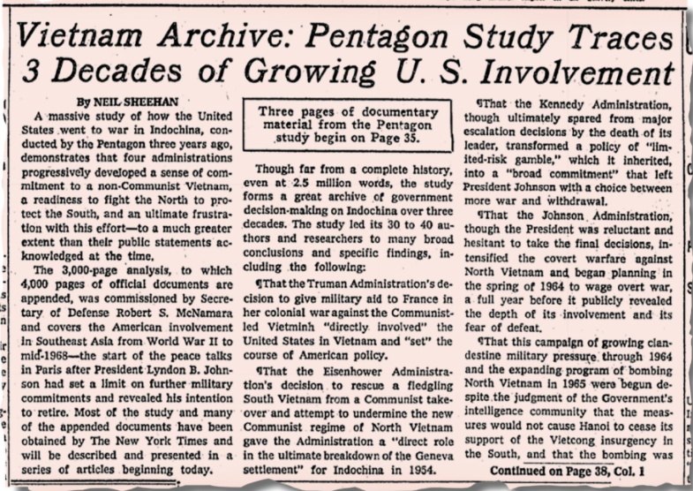

Document 5: Excerpt from the Pentagon Papers, leaked by Daniel Ellsburg and used by the New York Times in their coverage of the Vietnam War. The Under-Secretary of State mentioned was George Ball, who served the Kennedy administration, and his quote came from 1965. John McNaughton also served under the Kennedy administration. Found at http://www.famous-trials.com/ellsberg/272-excerpts
"This is our last clear chance to make this decision," the Under-Secretary asserted. And in a separate message to the President, he explained why: The decision you face now, therefore, is crucial. Once large numbers of US troops are committed to direct combat they will begin to take heavy casualties in a war they are ill-equipped to fight in a non-cooperative if not downright hostile countryside.
Once we suffer large casualties we will have started an almost irreversible process. Our involvement will be so great that we cannot--without national humiliation--stop short of achieving our complete objectives. Of the two possibilities 1 think humiliation would be more likely than the achievement of our objectives--even after we have paid terrible costs.
"Humiliation" was much on the minds of those involved in the making of American policy for Vietnam during the spring and summer of 1965. The word, or phrases meaning the same thing, appears in countless memoranda. No one put it as bluntly as Assistant Secretary of Defense John McNaughton, who in late March assigned relative weights to various American objectives in Vietnam. In McNaughton's view the principal U.S. aim was "to avoid a humiliating US defeat (to our reputation as a guarantor)." To this he assigned the weight of 70%. Second, but far less important at only 20% was "to keep South Vietnam (and then adjacent) territory from Chinese hands." And a minor third, at but 10%, was "to permit the people of South Vietnam to enjoy a better, freer way of life."

Document 6: Images from the covers of the Pentagon Papers. Found at https://www.archives.gov/research/pentagon-papers

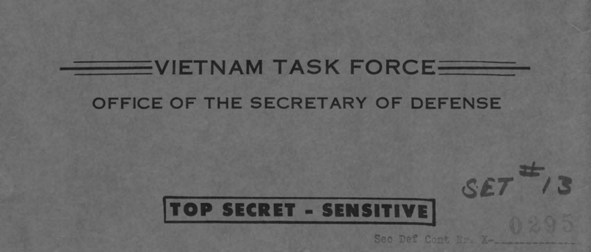

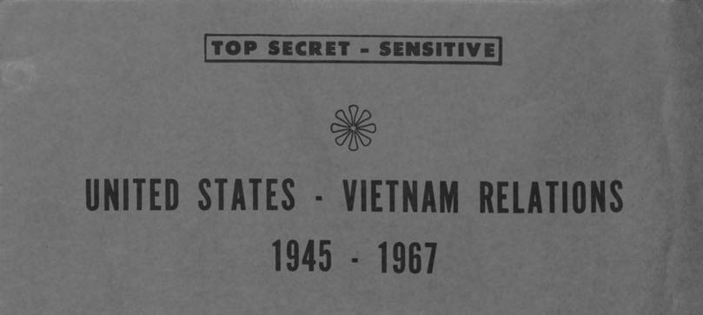

Document 7: Excerpt from the Pentagon Papers leaked by Daniel Ellsburg and used by the New York Times in their coverage of the Vietnam War. Roswell Gilpatrick was the Deputy Secretary of Defense in the Kennedy Administration and the person speaking was Robert McNamara, Secretary of State. McNamara was speaking to President Kennedy. Found at https://nara-media-001.s3.amazonaws.com/arcmedia/research/pentagon-papers/Pentagon-Papers-Part-IV-B-1.pdf
The Joint Chiefs, Mr. Gilpatric, and I have reached the following conclusions:
…The introduction of a U.S. force of the magnitude [size] of an initial 8,000 men in a flood relief context will be of great help to Diem [a U.S. allied Vietnamese leader]. However, it will not convince the other side (whether the shots are called from Moscow, Peiping, or Hanoi) that we mean business. Moreover, it probably will not tip the scales decisively. We would be almost certain to get increasingly mired down in an inconclusive struggle.

Document 8: Excerpt from the Pentagon Papers leaked by Daniel Ellsburg and used by the New York Times in their coverage of the Vietnam War. Hanoi was a city in North Vietnam, an enemy of the United States that was sending supplies to the VC (Vietcong), the U.S.’s enemies in the South. The South Vietnamese Kỳ regime was allied with the U.S. Found at https://nara-media-001.s3.amazonaws.com/arcmedia/research/pentagon-papers/Pentagon-Papers-Part-IV-B-1.pdf

There continues to be no sign that the bombing has reduced Hanoi's will to resist or her ability to ship the necessary supplies south. Hanoi shows no signs of ending the large war and advising the VC to melt into the jungles. The North Vietnamese believe they are right; they consider the Ky regime to be puppets [just doing what the U.S. wants]; they believe the world is with them and that the American public will not have staying power against them. Thus, although they may have factions in the regime favoring different approaches, they believe that, in the long run, they are stronger than we are for the purpose. They probably do not want to make significant concessions, and could not do so without serious loss of face.

Document 9: Excerpts from a recorded phone call between Republican President Richard Nixon and Secretary of State, Henry Kissinger, on June 13, 1971, after the report of the Pentagon Papers with excerpts appeared in the New York Times. [Changed to make it easier to read]. Found at Source: http://prde.upress.virginia.edu/conversations/4002137

Kissinger: I think they outsmarted themselves, because they had tried to make it "Nixon’s War," and what this [the Pentagon Papers] proves is that, if it’s anybody’s war, it’s Kennedy’s and Johnson’s.

President Nixon: Yeah.

Kissinger: So that these Democrats now complaining about where it went wrong—

President Nixon: Yeah.

Kissinger: —or what we’re doing wrong, this [chuckles] shows who’s responsible for the basic mess.

President Nixon: Yeah.

Kissinger: So I don’t think it’s having the effect that they intend.

President Nixon: Well, it may not have the effect they intend. The thing, though, is, Henry, that to me this is just unconscionable. This is treasonable action on the part of the people that put it out!

Kissinger: Exactly, Mr. President.

President Nixon: Doesn’t it involve secure information, a lot of other things? [Kissinger attempts to interject.] What kind of people would do such things?

Kissinger: It has the highest classified information, Mr. President.

President Nixon: Yeah. Yeah.

Kissinger: It’s treasonable. There’s no question we can charge them with it. I’m absolutely certain that this violates all sorts of security laws.

President Nixon: What do we do about it? Don’t we ask for an—

Kissinger: I think I should talk to [John N.] Mitchell (The Attorney General).

President Nixon: Yeah.

Document 10: Letter from John N. Mitchell, U.S. Atorney General, to Arthur Ochssulzberger, President of the New York Times Newspaper on June 14, 1971, after the New York Times had published excerpts from the Pentagon Papers on June 13 and 14, 1971. Found at https://www.nytimes.com/2016/06/30/insider/1971-supreme-court-allows-publication-of-pentagon-papers.html?

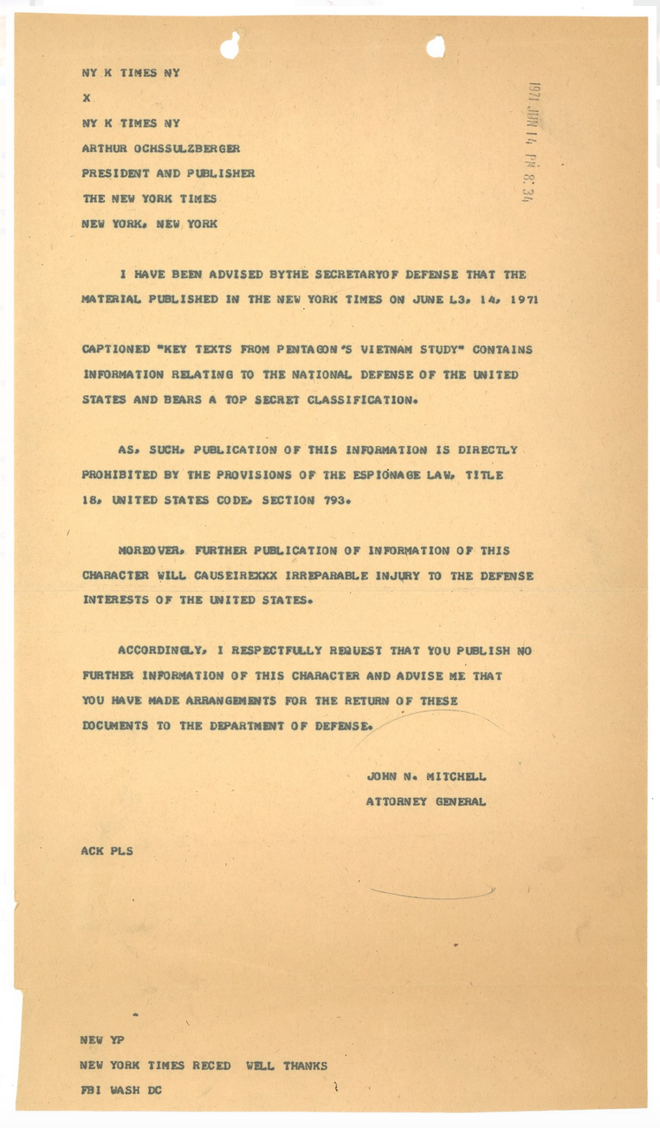

Document 11: Excerpt from the Supreme Court decision in the case of New York Times vs. United States. Justice Hugo Black wrote this concurring (agreeing) opinion, siding with the 6-3 majority. Found at https://supreme.justia.com/cases/federal/us/403/713/case.html

In the First Amendment, the Founding Fathers gave the free press the protection it must have to fulfill its essential role in our democracy. The press was to serve the governed, not the governors. The government's power to censor the press was abolished so that the press would remain forever free to censure the Government. The press was protected so that it could bare the secrets of government and inform the people. Only a free and unrestrained press can effectively expose deception in government. And paramount among the responsibilities of a free press is the duty to prevent any part of the government from deceiving the people and sending them off to distant lands to die of foreign fevers and foreign shot and shell. In my view, far from deserving condemnation for their courageous reporting, the New York Times, the Washington Post, and other newspapers should be commended for serving the purpose that the Founding Fathers saw so clearly. In revealing the workings of government that led to the Vietnam War, the newspapers nobly did precisely that which the Founders hoped and trusted they would do.

Document 12: Excerpt from the Supreme Court decision in the case of New York Times vs. United States. Justice Harry Blackmun wrote this dissenting (disagreeing) opinion, disagreeing with the 6-3 majority. [Changed to make easier to read]. Found at https://supreme.justia.com/cases/federal/us/403/713/case.html
The First Amendment is only a part of the Constitution. The Executive Branch is given power over dealing with other countries, and national security. Each part of the Constitution is valuable, and I don’t think that the First Amendment should be followed absolutely if it makes other parts of the Constitution be worth less…. I fear that Judge Wilkey's* statements make sense. So, I share his concern. I hope that damage has not already been done. If damage has been done, and the newspapers can be published after the Supreme Court’s decision, I fear that: more people will die, alliances will be destroyed, it will be harder to negotiate with enemies, diplomats will be unable to negotiate, the war will be prolonged, and US prisoners of war will be delayed in being freed. If these things happen, we know who is at fault.
* Judge Wilkey was on the District of Columbia Court of Appeals. He tried this case and ruled against the New York Times before the case was appealed to the U.S. Supreme Court

Teacher Background Information
The Pentagon Papers and Freedom of the Press

An ongoing question throughout U.S. history is “what are the best ways to protect civil rights without endangering national security?” For example, should newspapers or other media be allowed to publish information that could be harmful to national defense? What are the reasonable limits on freedom of the press? Should those who leak sensitive information to the press be prosecuted as traitors, or viewed as heroes if their “whistleblowing” leads to positive change? These questions are central to the debate over the leaked Pentagon Papers and the publishing of their contents in the New York Times, the Washington Post, and other newspapers. Controversy still surrounds the original publication of the papers. Even at the time, three members of the Supreme Court issued dissenting opinions on the issue. However here are a few facts, essential to understand the case of the Pentagon Papers, that most historians agree on:

- Before World War II, Vietnam was a French colony. After the war, the U.S. was afraid communism might spread into Vietnam. As early as 1945, the U.S. became very involved in France’s struggle to maintain control of Vietnam and interfered in Vietnam’s independence movement. In 1954, France withdrew from Vietnam and the nation was split, with communists controlling the North. Communist guerillas continued to fight for control of South Vietnam. In 1961, the United States’ military assumed a major role in fighting communists in South Vietnam. Their involvement spread into bombing in North Vietnam and invasions of neighboring countries. U.S. military action in Vietnam, which continued until 1975, is called the Vietnam War.
- In 1967, while the war was being fought, the U.S. Secretary of Defense, Robert McNamara, created the “Vietnam History Task Force” and asked them to write a report on U.S. involvement in Vietnam. The report, unlike any study done in previous wars, was intended to help historians understand the escalating U.S. involvement and presence in the conflict. Their report, the “Pentagon Papers,” was over 7,000 pages long. It summarized U.S. relations with Vietnam from 1945-1967, and included details of American mistakes and failed strategies. Authors of the report claimed that U.S. government officials had lied to the American public. They showed U.S. meddling in Vietnamese elections. They suggested American leadership was more worried about the humiliation of defeat than in protecting American lives. They revealed government officials’ doubts about the prospects of victory even early in the war. The report criticized the administrations of Truman, Eisenhower, Kennedy, and Johnson. Because the report provided information that could have emboldened American enemies in Vietnam, the government classified the Pentagon Papers as “top secret.”
- Daniel Ellsberg helped write the Pentagon Papers. After traveling to Vietnam and studying the war, Ellsberg began to become more certain that the Vietnam War was unjust. He started to attend anti-war events. In 1969, he decided to photocopy and share the Pentagon Papers with some anti-war senators and a New York Times newspaper reporter, Neil Sheehan. Ellsberg claimed that his duty as a patriot required him to do everything he could to stop the unjust war.
- On June 13, 1971, three years after the report had been produced but while the war continued, the New York Times began to publish excerpts from the Pentagon Papers with commentary. Even though the Pentagon Papers had been written before his presidency and did not criticize him personally, President Richard Nixon and his advisors viewed the publication of the excerpts as treasonous. His attorney general, John N. Mitchell asked the New York Times to stop publishing the excerpts. They refused to comply. After a third excerpt was published, the Nixon administration convinced the courts to order the New York Times to stop publishing.
- The New York Times appealed the injunction and the case quickly made its way to the U.S. Supreme Court. On June 30, 1971, by a vote of 6 to 3, the Supreme Court ruled that the New York Times could again publish articles containing excerpts from the Pentagon Papers. This case of the New York Times Co. v. United States is still an important test of the free press. At the time, it showed a divided opinion of the justices that mirrored the divided opinion of the general American public.
- Ellsberg shared the Pentagon Papers with other reporters, including some from the Washington Post, and with senators. After the injunction was issued stopping the New York Times from publishing the Pentagon Papers, the Washington Post began to publish excerpts. Within a few months, more than half of the Pentagon Papers were available to the public through the Congressional Record. Since 2011, the entire Pentagon Papers have been available and can currently be found online in the National Archives at https://www.archives.gov/research/pentagon-papers
- In a case separate from the Supreme Court decision, Ellsberg and a friend were charged with violating the Espionage Act of 1917. The Nixon team used illegal means to collect evidence (strategies that would later be employed in the Watergate burglaries), and appeared to influence a judge with the promise of a promotion in the federal government. The case against Ellsberg was dismissed when court officials discovered the illegal means used to gather evidence against Ellsberg and the other irregularities.

Students will be given a number of documents related to the publication of the Pentagon Papers. They will need to answer the questions: “Was Ellsberg guilty of violating the Espionage Act of 1917? And, “was the Supreme Court wise in allowing the New York Times to publish excerpts from the Pentagon Papers?” You can have students annotate the documents, or use the attached worksheet to gather evidence to support their conclusion.

Original Documents
The Pentagon Papers and Freedom of the Press

Document 1: The Espionage Act of June 15, 1917, Section 1. Found at http://www.digitalhistory.uh.edu/disp_textbook.cfm?smtID=3&psid=3904

That: (a) whoever, for the purpose of obtaining information respecting the national defence with intent or reason to believe that the information to be obtained is to be used to the injury of the United States, or to the advantage of any foreign nation, goes upon, enters, flies over, or otherwise obtains information, concerning any vessel, aircraft, work of defence, navy yard, naval station, submarine base, coaling station, fort, battery, torpedo station, dockyard, canal, railroad, arsenal, camp, factory, mine, telegraph, telephone, wireless, or signal station, building, office, or other place connected with the national defence, owned or constructed, or in progress of construction by the United States or under the control or the United States, or of any of its officers or agents, or within the exclusive jurisdiction of the United States, or any place in which any vessel, aircraft, arms, munitions, or other materials or instruments for use in time of war are being made, prepared, repaired. or stored, under any contract or agreement with the United States, or with any person on behalf of the United States, or otherwise on behalf of the United States, or any prohibited place within the meaning of section six of this title; or

(b) whoever for the purpose aforesaid, and with like intent or reason to believe, copies, takes, makes, or obtains, or attempts, or induces or aids another to copy, take, make, or obtain, any sketch, photograph, photographic negative, blue print, plan, map, model, instrument, appliance, document, writing or note of anything connected with the national defence; or

(c) whoever, for the purpose aforesaid, receives or obtains or agrees or attempts or induces or aids another to receive or obtain from any other person, or from any source whatever, any document, writing, code book, signal book, sketch, photograph, photographic negative, blue print, plan, map, model, instrument, appliance, or note, of anything connected with the national defence, knowing or having reason to believe, at the time he receives or obtains, or agrees or attempts or induces or aids another to receive or obtain it, that it has been or will be obtained, taken, made or disposed of by any person contrary to the provisions of this title; or

(d) whoever, lawfully or unlawfully having possession of, access to, control over, or being entrusted with any document, writing, code book, signal book, sketch, photograph, photographic negative, blue print, plan, map, model, instrument, appliance, or note relating to the national defence, wilfully communicates or transmits or attempts to communicate or transmit the same and fails to deliver it on demand to the officer or employee of the United States entitled to receive it; or

(e) whoever, being entrusted with or having lawful possession or control of any document, writing, code book, signal book, sketch, photograph, photographic negative, blue print, plan, map, model, note, or information, relating to the national defence, through gross negligence permits the same to be removed from its proper place of custody or delivered to anyone in violation of his trust, or to be list, stolen, abstracted, or destroyed, shall be punished by a fine of not more than $10,000, or by imprisonment for not more than two years, or both.
Document 2: An excerpt from Daniel Ellsberg’s book, Papers of the War. Found in Ellsberg, D. (1973). Papers on the War. New York: Simon & Schuster.

For over seven years, like many other Americans I have been preoccupied with our involvement in Vietnam. In that time I have seen it first as a problem; then as a stalemate; then as a crime.

Each of these perspectives called for a different mode of personal commitment: a problem, to help solve it; a stalemate, to help extricate ourselves with grace; a crime, to expose and resist it, to try to stop it immediately, to seek moral and political change.

Document 3: Excerpts from Daniel Ellsberg’s autobiography. Found in Ellsberg, D. (2003). Secrets: A Memoir of Vietnam and the Pentagon Papers pp 41,44. New York: Penguin.

"Even when I regarded the administration's policy as inadequate or misguided, as I often did on nuclear matters, I saw little hope for improvement by Congress [...] Once I was inside the government, my awareness of how easily and pervasively Congress, the public, and journalists were fooled and misled contributed to a lack of respect for them and their potential contribution to better policy. That in turn made it easier to accept, to participate in, to keep quiet about practices of secrecy and deception that fooled them further and kept them ignorant of the real issues that were occupying and dividing inside policy makers. Their resulting ignorance made it all the more obvious that they must leave these problems to us."

"It became clear to me that journalists had no idea, no clue, even the best of them, just how often and how egregiously they were lied to."

"The lies themselves didn't bother me, but there were several cases that year when I thought a false story was so likely to be found out that it made me nervous [...] One morning just before eight o'clock [John, my boss, ...] said to me, 'A [spy] drone has gone down in China. Bob is seeing the press at eight-thirty. We have ten minutes to write six alternative lies for him.' [...] John threw me a yellow pad, and I pulled up a chair to the opposite side of his desk. We sat across from each other and wrote as fast as we could for ten minutes. [...] The first ones were obvious [...] If the Chinese had already announced the incident, one, we had no idea whose plane it was; it wasn't one of ours. Two, it was a Chinese Nationalist plane. [...] Three, it was an experimental drone, off course. Four, it was taking weather readings when it went off course. [...John] looked at the clock, ten minutes, grabbed my pad and started to run out, looking down at my six entries. [...] A few minutes later he was back and waved me down to his desk again. He tore off the pages we'd written on and pushed one of the pads back to me. He said, 'Bob liked these. He wants four more. We have five minutes.'"

"Within weeks of my arrival I found myself immersed in what seemed the most urgent concrete problem of uncertainty and decision that humanity had ever had to face: averting a nuclear exchange between the Soviet Union and the United States. [...] The danger of nuclear war, possibly U.S.-initiated, continued to be very real for me, perhaps resulting from an accident, unauthorized action, the interaction of alerts or feints in a crisis, a false alarm, or misunderstood commands."
Document 9: Excerpts from a recorded phone call between President Richard Nixon and Secretary of State, Henry Kissinger, on June 13, 1971, after the report of the Pentagon Papers with excerpts appeared in the New York Times. Recording 2:36-5:10. Found at Source: http://prde.upress.virginia.edu/conversations/4002137

President Nixon: Well, that's—Haig was very disturbed by that New York Times thing. I thought that—

Kissinger: Well, Mr. President, I think—

President Nixon: Unconscionable damn thing for them to do.

Kissinger: It is unconscionable [unclear]—

President Nixon: Of course, it’s . . . it's . . . it's unconscionable on the part of the people that leaked it. Fortunately, it didn’t come out on our administration. [Kissinger attempts to interject.] That appar—according to Haig, it’s all relates to the two previous administrations. Is that correct?

Kissinger: That is right.

President Nixon: But I hope [Kissinger attempts to interject] the—but I—my point is if—are any of the people there who participated in this thing, who—in leaking it? That’s my point. Do we know?

Kissinger: In public opinion, it actually, if anything, will help us a little bit, because this is a gold mine of showing how the previous administration got us in there.

President Nixon: I didn’t read the thing. Tell—give me your view on that in a word.

Kissinger: Oh, well, it just shows massive mismanagement of how we got there. And it pins it all on [John F.] Kennedy and [Lyndon B.] Johnson.

President Nixon: [laughing] Yeah.

Kissinger: And [Robert S.] McNamara. So from that point of view, it helps us. From the point of view of the relations with Hanoi, it hurts a little, because it just shows a further weakening of resolve.

President Nixon: Yeah.

Kissinger: And a further big issue.

President Nixon: [Pause.] I suppose the Times ran it to try to affect the debate this week or something.

Kissinger: Oh, yes. No question about it.

President Nixon: Well, it—I don’t think it’s going to have that kind of effect.

Kissinger: No. No, because it’s—in a way, it shows . . . what they’ve tried to do—I think they outsmarted themselves, because they had put themselves—they had sort of tried to make it "Nixon’s War," and what this massively proves is that, if it’s anybody’s war, it’s Kennedy’s and Johnson’s.

President Nixon: Yeah.

Kissinger: So that these Democrats now bleating about where it went wrong—

President Nixon: Yeah.

Kissinger: —or what we’re doing wrong, this graphically [chuckles] shows that—who’s responsible for the basic mess.

President Nixon: Yeah.

Kissinger: So I don’t think it’s having the effect that they intend.

President Nixon: Well, you know . . . it's—it may not have the effect they intend. The thing, though, that, Henry, that to me is just unconscionable, this is treasonable action on the part of the bastards that put it out!

Kissinger: Exactly, Mr. President.

President Nixon: Doesn’t it involve secure information, a lot of other things? [Kissinger attempts to interject.] What kind of people would do such things?

Kissinger: It has the most—it has the highest classifications, Mr. President.

President Nixon: Yeah. Yeah.

Kissinger: It’s treasonable. There’s no question it’s actionable. I’m absolutely certain that this violates all sorts of security laws.

President Nixon: What do we do about it? Don’t we ask for an—

Kissinger: I think I should talk to [John N.] Mitchell.

President Nixon: Yeah.

Document 12: Excerpt from the Supreme Court Decision in the case of New York Times vs. United States. Justice Harry Blackmun wrote this dissenting (disagreeing) opinion, disagreeing with the 6-3 majority. [Changed to make easier to read]. Found at http:// https://supreme.justia.com/cases/federal/us/403/713/case.html

The country would be none the worse off were the cases tried quickly, to be sure, but in the customary and properly deliberative manner. The most recent of the material, it is said, dates no later than 1968, already about three years ago, and the Times itself took three months to formulate its plan of procedure and, thus, deprived its public for that period. The First Amendment, after all, is only one part of an entire Constitution. Article II of the great document vests in the Executive Branch primary power over the conduct of foreign affairs, and places in that branch the responsibility for the Nation's safety. Each provision of the Constitution is important, and I cannot subscribe to a doctrine of unlimited absolutism for the First Amendment at the cost of downgrading other provisions…. I fear that Judge Wilkey's statements have possible foundation. I therefore share his concern. I hope that damage has not already been done. If, however, damage has been done, and if, with the Court's action today, these newspapers proceed to publish the critical documents and there results therefrom "the death of soldiers, the destruction of alliances, the greatly increased difficulty of negotiation with our enemies, the inability of our diplomats to negotiate," to which list I might add the factors of prolongation of the war and of further delay in the freeing of United States prisoners, then the Nation's people will know where the responsibility for these sad consequences rests.

